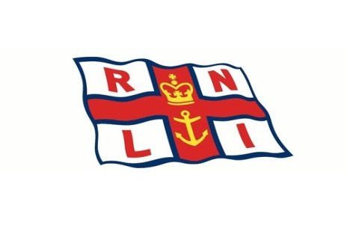
Fundraising in aid of the RNLI

Larne R.N.L.I. presents

A Fun Beetle Drive
at East Antrim Boat Club
7:30pm Saturday 29 February
Tickets….£10 per person includes light supper and complimentary drink
For tickets please contact Larne Fundraising Group
07516496945 or 07718067747
All Welcome

